

|  |  |  |  |  |  |
| --- | --- | --- | --- | --- | --- |
|  | | | | | |
|  | | | Pet Insurance |  | |
|  | | |  |  | |
|  | |  | | |  |
|  | | Group 6 **Matej Mestrovic**  **Vishal Reddy Musku**  **Srija Jasthi** **8th October 2023**—**MIT 5732****—****DR. RADHIKA SANTHANAM** | | |  |
|  | |  | | |  |
|  |

# Table of content

##### Introduction

##### Importance of Pet Insurance

##### Data description

##### Data Analysis

##### Conclusions & Recommendations

##### References

# Introduction

Pet insurance is a type of health coverage for animals, designed to help pet owners offset the costs of veterinary care. Similar to human health insurance, Pet insurance serves as a financial safety measure against substantial veterinary expenses, such as serious illnesses or injuries. Without this coverage, pet owners are fully responsible for all veterinary costs. In situations where pet owner encounters a significant veterinary bill, the total amount paid in insurance premiums may be substantially less than the reimbursement received. The primary objective of pet insurance is to offer financial protection against considerable veterinary expenditures. Policyholders pay a monthly or yearly premium, and in return, the insurer offers coverage for certain veterinary services, which can range from routine checkups to emergency surgeries. Coverage options and costs vary widely, depending on factors like the type of pet, its age, breed, and where you live. Some policies might cover accidents only, while others may cover both accidents and illnesses. There are also comprehensive plans that provide coverage for preventive care, such as vaccinations and annual check-ups. Often, pet owners can choose their deductible and reimbursement levels, allowing them to customize the policy to fit their budget and needs. It empowers pet owners to prioritize their pet's health without the worry of unmanageable costs. Pet insurance has witnessed remarkable growth over the past few years. Pet insurance has been growing in popularity. There was a 28% increase in total insured pets in the U.S. from 2020 to 2021, according to the North American Pet Health Insurance Association (NAPHIA). Dogs overwhelmingly represent the majority of insured pets (82%) compared to cats (18%). The rise in pet insurance might be partially attributed to the pandemic. More than three-quarters (78%) of pet owners said they acquired a pet during the pandemic, according to a Forbes Advisor survey. Pet insurance industry has been on a growth trajectory in recent years. Increased marketing efforts and consumer education about the benefits of pet insurance have contributed to its growth. Rising veterinary costs, combined with the increasing humanization of pets and heightened awareness about insurance benefits, have been major drivers behind this trend. As pets continue to hold a special place in households globally, the demand for pet insurance is likely to persist and even accelerate.

#### Importance of Pet Insurance

Pet insurance is a vital tool that prioritizes the well-being of pets while also safeguarding the financial stability of their owners. The bond between pets and their owners is deeply ingrained, leading many to view their pets as integral family members. This emotional connection underscores the need to ensure their health and safety. Unfortunately, like humans, pets are not immune to illnesses or injuries, and the ensuing veterinary expenses can be daunting, pets can encounter unexpected health challenges, from injuries to illnesses. A primary reason of pet insurance is the financial cushion it offers against unforeseen medical bills. Treatments, especially specialized ones such as cancer therapy, orthopedic surgeries, or even advanced diagnostics, can be prohibitively expensive. As pets age, their susceptibility to health issues increases. In these scenarios, having insurance proves indispensable, ensuring they receive the requisite care without causing economic strain on their owners. Insurance alleviates this financial burden, allowing owners to pursue the best available medical care for their pets without significant financial hesitancy. It transforms potentially out-of-reach treatments into accessible options, ensuring pets receive the care they deserve. Moreover, the consistent nature of insurance premiums allows for predictability. Owners can budget for these fixed monthly or annual expenses rather than being blindsided by unexpected, hefty veterinary charges. This forward-planning eases the minds of pet owners, knowing they are economically prepared for sudden health eventualities. The aging process in pets, much like in humans, often brings a higher likelihood of health concerns. Here, insurance shines as armor, especially for older pets, ensuring they receive necessary treatments without causing undue financial pressure on their owners. Pet insurance can greatly reduce the frequency of such heart-wrenching decisions. Additionally, certain insurance packages emphasize preventive care, covering regular check-ups, vaccinations, and even dental care. This not only encourages routine veterinary visits but also emphasizes a proactive stance on pet health. Early detection often translates to more effective treatments and better health outcomes. In essence, pet insurance serves as both a protective shield against unpredictable medical expenses and a means of ensuring that pets, regardless of age or health status, receive the best care possible. Pet insurance not only provides financial security but also empowers pet owners to act promptly in crisis situations, optimizing the health and recovery outcomes for their beloved pets.

**Data Preparation**

We utilized two distinct sources of data to conduct this comprehensive analysis. The first source is the PetsData table, which utilizes the primary key, PetID, to uniquely identify each pet in the dataset. Our second data source is the claims data, which employs ClaimID as the primary key and PetID as a foreign key, allowing it to reference the information provided in the first data source.

**PetsData:**

* PetId - This column contains a unique identifier for each individual pet covered by the insurance policy. It helps to distinguish and track specific pets throughout the claims data
* Species - Data consists of two species of pets, cats and dogs (with dogs outnumbering cats 5 to 1)
* Breed - Observed 373 unique breeds in total (55 cat and 318 dog)
* Age - The age of the pet is recorded during the first year of its enrollment in the insurance. Pets' ages can vary from 0 (meaning less than 1 year old) to 13 years old.
* Premium - Premiums fall into a wide range with a few outlier values close to $1000
* Deductible - Deductibles are fairly well distributed and appear to be stratified across a range of common values
* AmtClaimsYr1: This column represents the total amount of claims made by policyholders for veterinary expenses during the first year of their insurance coverage.
* AmtClaimsYr2: This column shows the total amount of claims made by policyholders for veterinary expenses during the second year of their insurance coverage.
* AvgClaimsYr1: This column displays the average amount of each claim made by policyholders during the first year of their insurance coverage.
* AvgClaimsYr2: This column indicates the average amount of each claim made by policyholders during the second year of their insurance coverage
* NumClaimsYr1: This column represents the total number of claims submitted by policyholders during the first year of their insurance coverage.
* NumClaimsYr2: This column shows the total number of claims submitted by policyholders during the second year of their insurance coverage.
* AmtClaimsTotal: This column displays the cumulative total amount of claims made by policyholders since the beginning of their insurance coverage until the present.
* AvgClaimsTotal: This column indicates the average amount of each claim made by policyholders since the beginning of their insurance coverage until the present.
* NumClaimsTotal: This column represents the overall total number of claims submitted by policyholders since the beginning of their insurance coverage until the present.
* YrsWithClaims: This column shows the number of years in which policyholders have submitted claims for veterinary expenses since joining the insurance.

**ClaimsData**

* PetId: This column contains a unique identifier for each individual pet covered by the insurance policy. It helps to distinguish and track specific pets throughout the claims data.
* ClaimId: This column contains a unique identifier for each claim made by the policyholders for their pets. It serves as a reference number for each claim and helps to organize and manage the claims data efficiently.
* ClaimDate: This column records the date on which each claim was made by the policyholder for veterinary expenses incurred by their pet. It helps to keep track of the timeline of claim submissions.
* AmountClaimed: This column indicates the monetary amount claimed by the policyholder for each specific claim. It represents the veterinary expenses that the policyholder is seeking reimbursement for from the insurance compan

##### Data Analysis

##### Categorization of pets into age groups.

The objective was to categorize pets into three distinct age groups using Tableau. This classification would enable us to understand and analyze the characteristics and behaviors of pets in different stages of their lives more effectively. To achieve this, we employed a statistical method known as cluster analysis. Cluster analysis is a type of unsupervised machine learning method that involves grouping objects in such a way that objects in the same group (called a cluster) are more similar to each other than to those in other groups (clusters). It’s a powerful tool for data interpretation, pattern recognition, and deriving meaningful insights from large datasets. In our case, we used Tableau’s built-in clustering feature to group pets based on their ages. We decided to form three clusters representing three age groups: young, middle-aged, and old. After performing the cluster analysis, we found the following age ranges for each group.The young group includes pets that are aged between 0 and 2 years. These are generally the most energetic and playful pets, requiring plenty of care and attention. Pets that fall within the age range of 3 to 6 years are categorized into the Middle-aged group. These pets have typically outgrown their youthful exuberance but are still active and require regular exercise. Finally, the older group, pets that are 7 years old or older fall into this category. These pets may be less active and may require special care and attention due to potential health issues associated with old age.

This categorization was instrumental in understanding the characteristics of pets at different stages of their lives. Below is the visualization (fig 1) that shows us three different clusters in 3 different colors representing 3 different age groups.

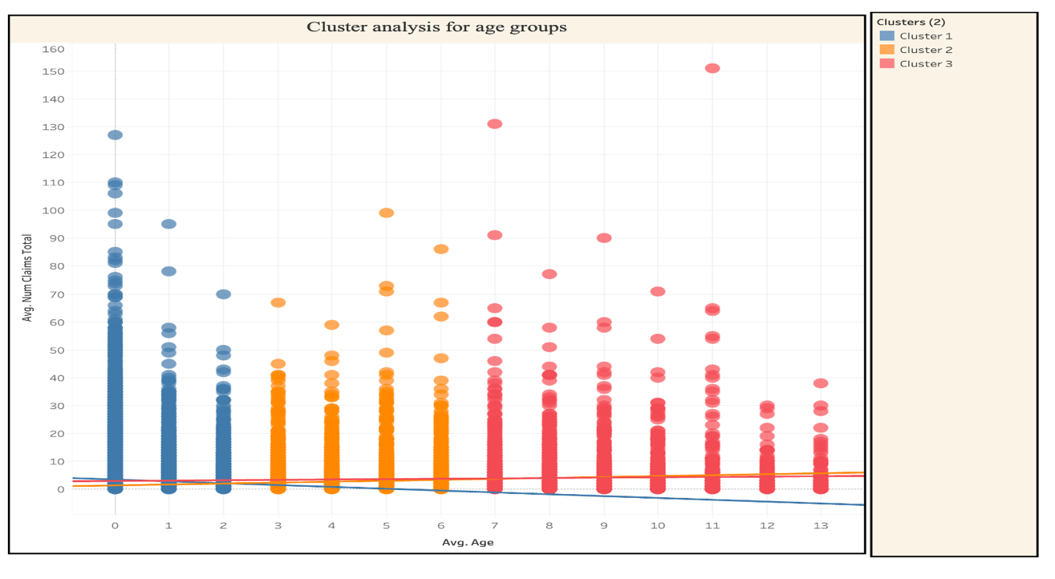

Fig 1

**Distribution of pets**

In our analysis, we categorized pets into different age groups and examined their distribution by species and age. The 'Distribution of pets' dashboard provides insights into the total number of insured pets in the U.S. from 2018 to 2020. The data reveals that dogs significantly outnumber cats in the insured pet population, with approximately 41,976 insured dogs compared to 8,024 insured cats.

Furthermore, we investigated the age composition of insured pets, finding that young pets are the most insured across all species. In both dogs and cats, the younger age groups account for a significant portion of the insured population. To provide a more detailed perspective, filter options have been included in the dashboard. These filters enable users to explore variations in pet distribution by species and when considering both species together. Notably, in the dog category, younger pets constitute a significant 80% of the total, reflecting their prevalence among insured dogs. Similarly, in the case of cats, the younger age groups make up almost 70% of the total cat population in our dataset.

This analysis illuminates compelling trends in pet insurance demographics, emphasizing the popularity of dogs and the preference for insuring younger pets. These findings can guide insurance providers in tailoring their offerings and understanding customer preferences.

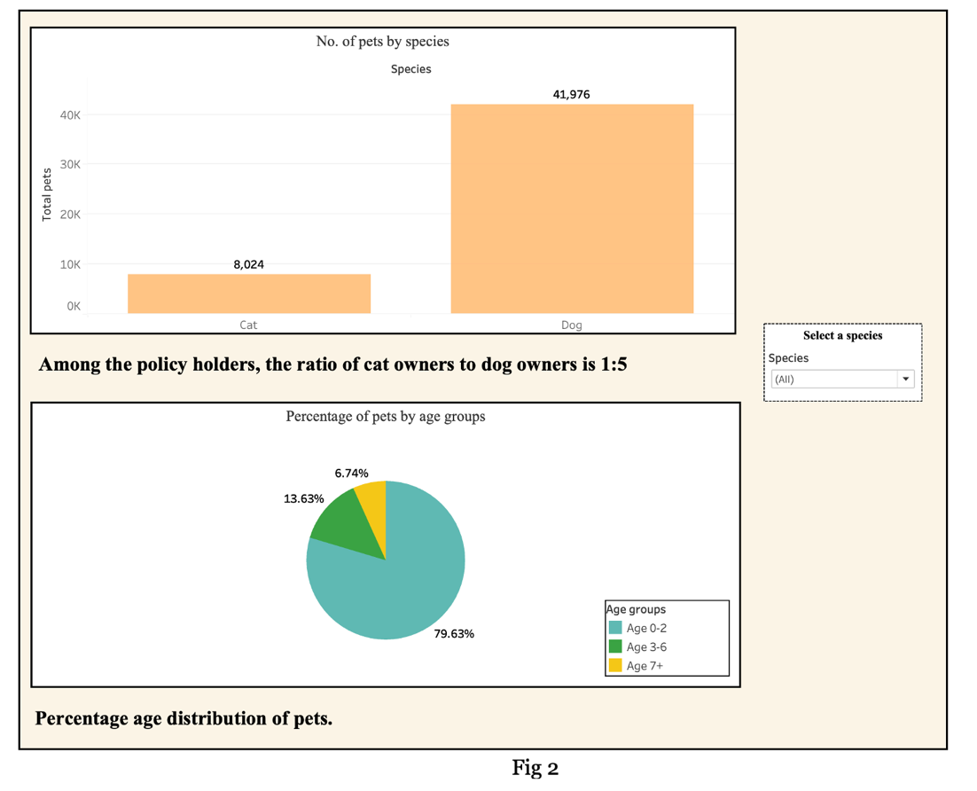

##### Most popular breeds among the pet owners by species

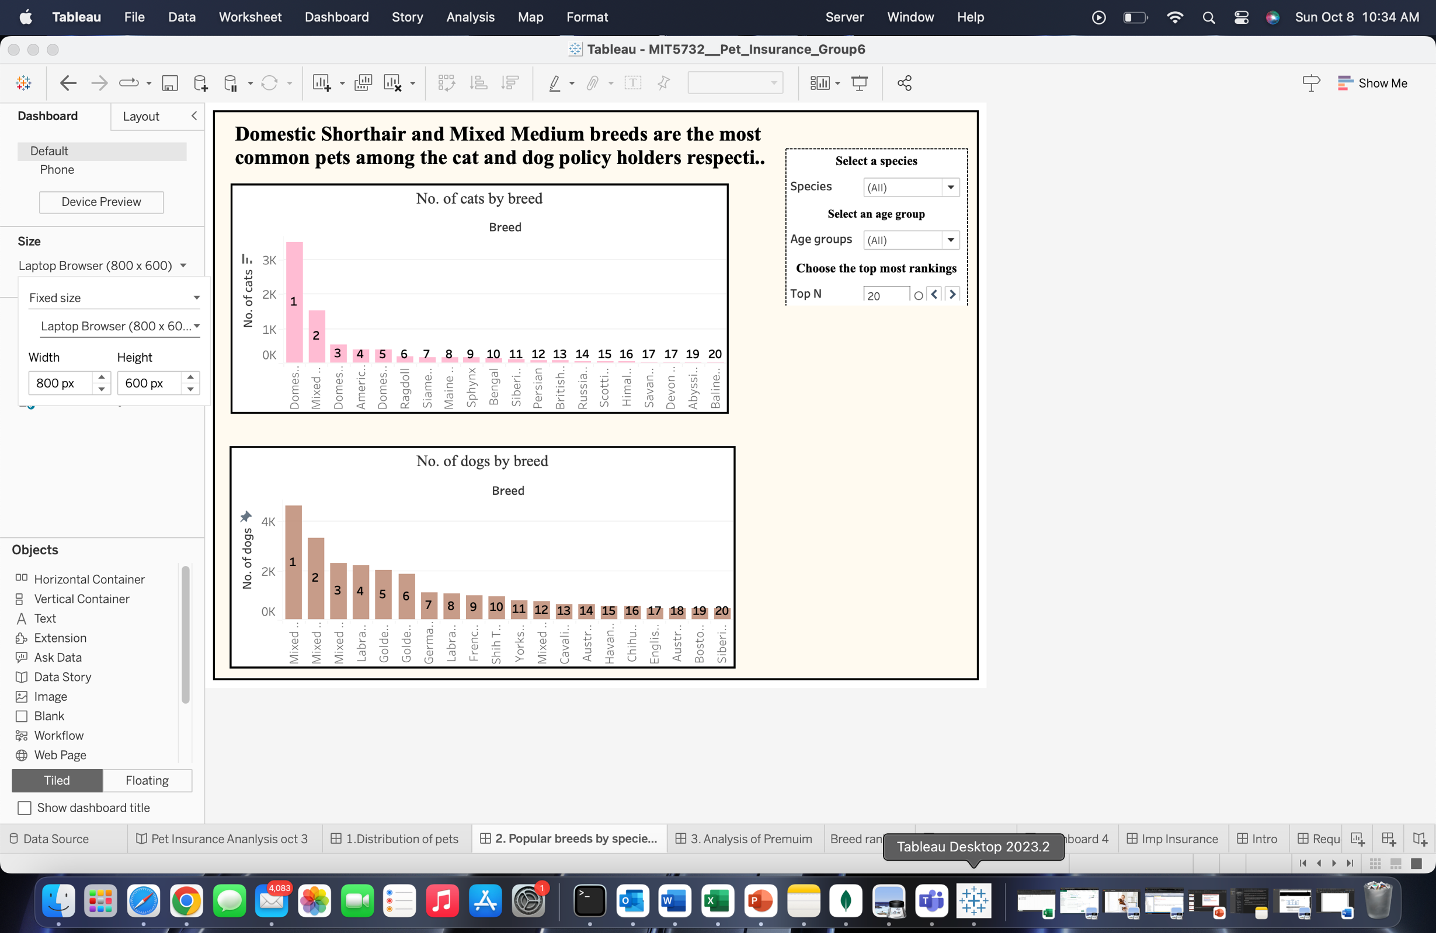

##### The analysis represents the preferences of pet owners, highlighting the popularity of the Domestic shorthair among cats and Mixed medium breeds in dogs. This information offers more than just a snapshot of breed selection; it paves the way for several strategic initiatives. By understanding these breed preferences, the insurance company can design packages that cater specifically to the health profiles and potential ailments associated with these breeds. This targeted approach can also be mirrored in marketing campaigns, allowing for materials that emphasize the benefits of insurance for these popular breeds, resonating with a broader segment of pet owners. Furthermore, recognizing the health care requirements of these leading breeds can help insurance company tailor the insurance packages, potentially refining the pricing model based on the general health risks associated with each breed. In essence, this breed-centric analysis not only illuminates pet owner preferences but also offers a roadmap for the insurance company to optimize its services, fostering a more tailored and efficient approach the policyholders.

#### Most vulnerable breeds by species

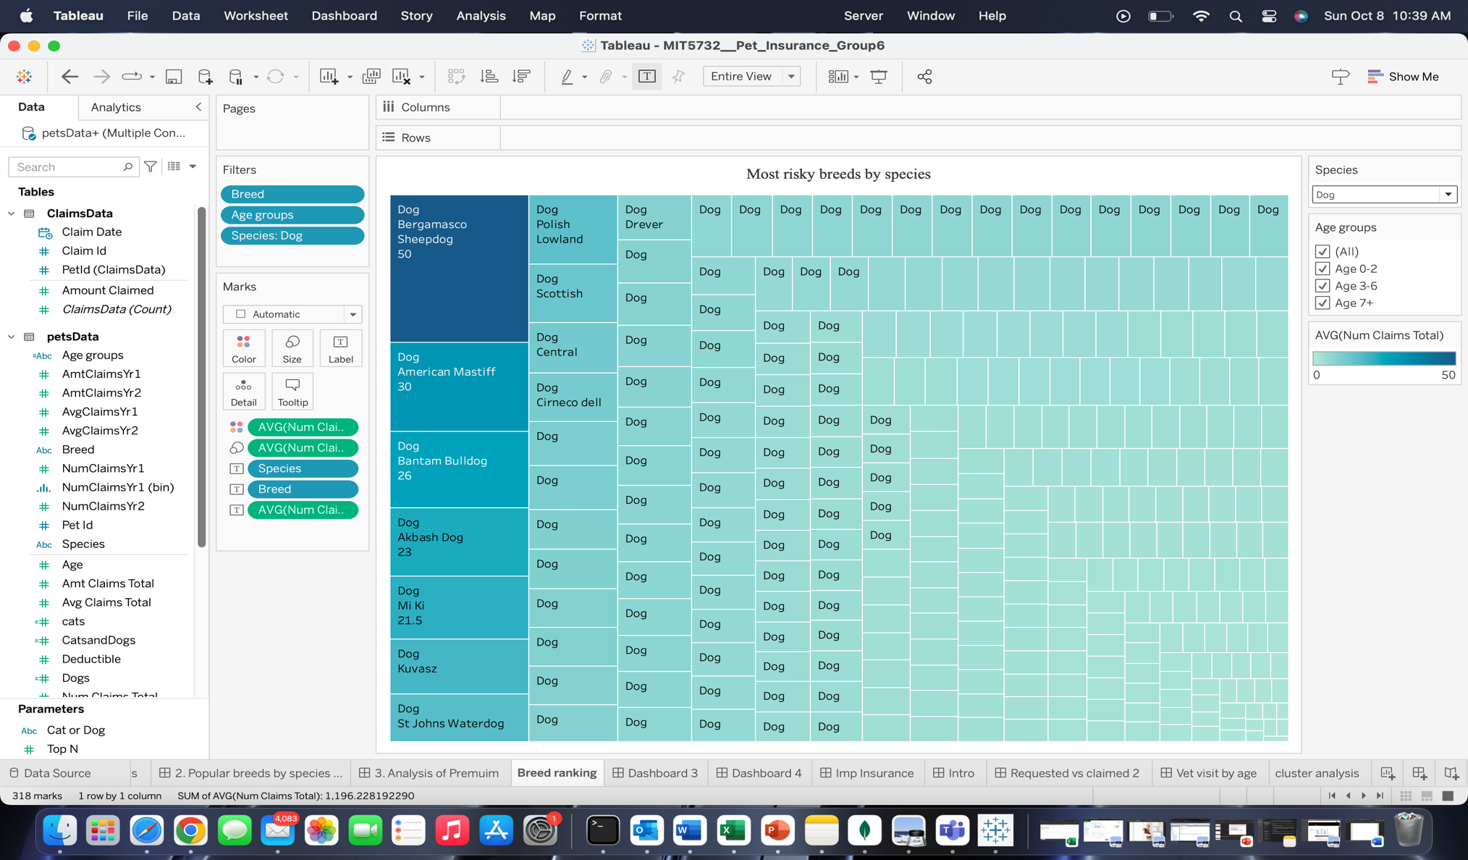



This analysis provides an insightful perspective on the breed-specific tendencies regarding veterinary visits and subsequent insurance claims. By categorizing breeds based on the frequency of claims made, we discern a clear pattern of certain breeds visiting the vet more often than others. While this doesn't necessarily equate to these breeds being more prone to illnesses, it does highlight their higher engagement with veterinary services, which could range from regular checkups to treatment for specific conditions. The underlying reasons for these frequent visits remain undetermined. However, these findings present an invaluable opportunity for insurance companies. Recognizing and understanding these trends can guide the refinement of insurance packages. Tailored policies can be developed, ensuring that the insurance remains both beneficial for the pet owner and sustainable for the insurer. This data-driven approach will also empower the company to strike a balance, ensuring that the premiums collected align with the claims disbursed, thus mitigating potential financial discrepancies. Furthermore, this breed-specific claim data can also influence the company's risk assessment models and pricing structures, ensuring a more accurate reflection of potential liabilities. In summation, this in-depth analysis not only sheds light on breed-specific veterinary engagement but also equips the insurance company with critical data, fostering the development of more nuanced and financially viable insurance offerings. Understanding which breeds are more frequently seen can lead to partnerships offering discounted check-ups or specialized care packages, further enhancing the value proposition of the insurance policy. Lastly, on a broader scale, this data can shape community outreach or educational campaigns. By recognizing breeds with higher engagement, insurers can create targeted information sessions or resources that address common concerns or needs specific to those breeds.

#### Correlation between Premium and Age

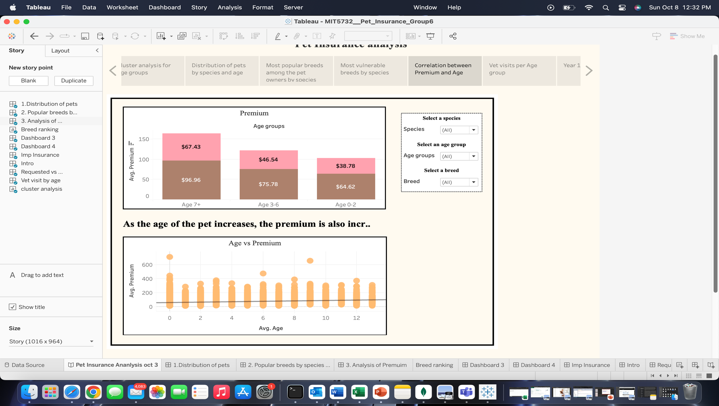

The analysis depicts the correlation between the age of pets and the associated insurance premium prices. A discernible trend emerges from the data: as pets age, the cost of their insurance premiums rises. Specifically, premiums for older pets are notably higher than for their middle-aged counterparts, and similarly, middle-aged pets face higher premiums than younger ones. This trend can be attributed to several factors. Older pets, much like older humans, tend to have more health issues or are at a higher risk for certain conditions, thereby potentially leading to more frequent or costly vet visits. This increased risk makes insuring them more expensive. Conversely, younger pets, being in the prime of their health, are less likely to incur significant medical expenses, justifying their lower premiums. Each life stage comes with its own set of health considerations, which insurance companies factor into their premium pricing. In essence, the correlation between pet age and insurance premium prices underscores the risk-based assessment that insurers use to determine pricing. It ensures that the premium charged aligns with the potential veterinary costs associated with pets at different stages of their lives. This age-based pricing structure, while seeming tiered, ensures a balanced and fair approach, reflecting the potential health care costs of pets at various life stages.

We wanted to delve deeper into the pricing mechanisms employed by insurance companies to identify how they determine premium costs. Specifically, we wanted to understand whether these prices are set based on trend analyses, drawing from historical data and patterns, or if they are determined through a generalized analysis that predominantly considers age-related factors.

##### Vet visits per Age group

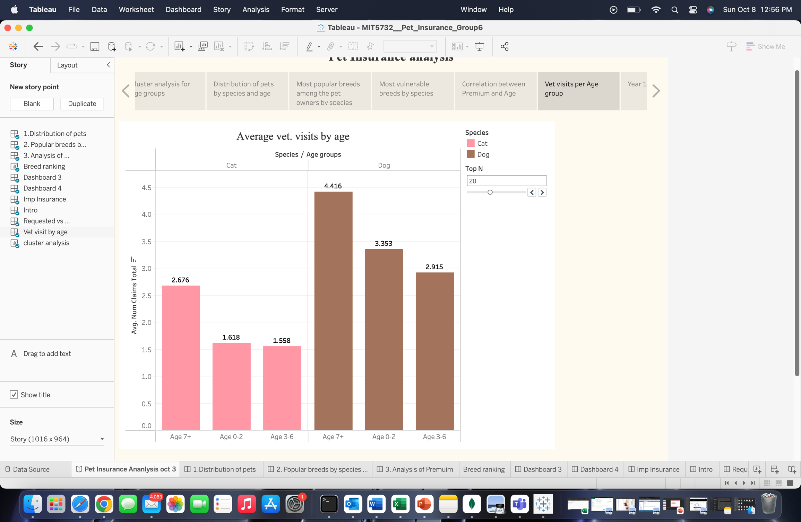

##### Upon examining the average number of claims submitted by policyholders segmented by pet age groups, an intriguing pattern emerges. Contrary to initial expectations, the frequency of claims is not directly correlated with the age of the pets. Instead, older pets have the highest number of claims, followed by younger pets, with middle-aged pets registering the fewest claims. This deviation from expected trends suggests that age alone isn't the primary determinant for claims. Several factors might account for this pattern. Older pets, as they age, naturally require more medical attention due to age-related ailments and conditions, thereby leading to higher claims. On the other hand, younger pets, while generally in good health, frequently visit vets for routine procedures such as vaccinations, check-ups, and neutering, contributing to their elevated claim numbers. Middle-aged pets, possibly being in their health prime, might not have as many health-related requirements, explaining their fewer claims. This analysis offers a valuable perspective for insurance companies. Understanding these patterns can inform refinements to policy structures and pricing. Instead of a one-size-fits-all approach based purely on age, the insurance offerings can be nuanced to account for the specific needs and claim patterns of pets at various life stages. This data-driven approach can help insurers tailor their services more effectively, ensuring comprehensive coverage for pets while maintaining the sustainability and profitability of their offerings.

#### DASHBOARD 3 – Year 1 (2018) changes in number of claims and Dollar amount of claims

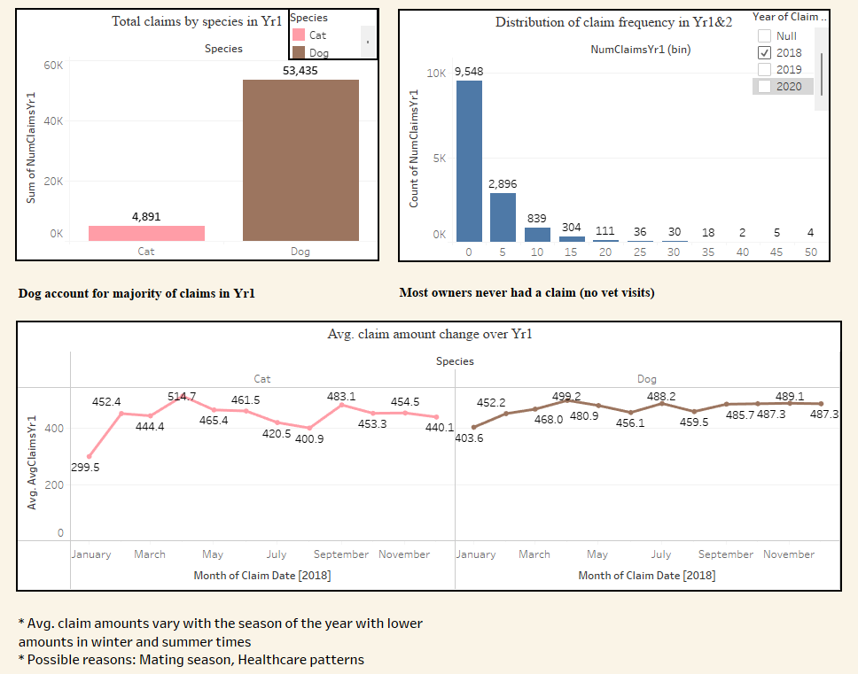  
In Dashboard 3 we take a more detailed look into the yearly number of claims, frequencies and we compare average claim amounts between cats and dogs. In the “Total claims by species in Yr1” bar chart graph we compare total number of claims made for each pet species. In our case we are comparing Cats and Dogs and from the graph we can see that there are substantially more claims made for Dogs. Dog owners have made 53,435 claims compared to cat owners who only made 4,891 claims in the first year. Even though these numbers are very different we have to keep in mind that there are about 40,000 dogs and 8,000 cats insured.

To fully understand what this means we must look at the frequency of claims made in the first year. For this we look at the “Distribution of claim frequency in Yr1&2” bar chart that shows how many pets had 0/5/10/15/20... claims in the first year. We can see that there are almost 10,000 pets for which owners never had a claim, and the number of claims per pet reduces with the increase in frequency of claims. We can see that there are only 2,896 pets with 5 claims and 839 pets with 10 claims. This tells us that some pets might frequent vet visits more than others, depending on species and breed.   
  
Finally in the “Avg. Claim amount change over Yr1” line chart shows us the movement of average Dollar amount of claims per month in the first year, the 2018. Upon looking at the graph and noticing patterns and combining it with our knowledge of dogs or cats we realized that mating and healthcare patterns (regular checkups) might have an influence over the fluctuations of the average claim amount. For cats the fluctuations are a bit more obvious compared with dogs, but they both have an increasing and decreasing periods in the year. For cats, we have an increasing period of claim amounts between January and April and then a longer decreasing period between April and August after which the claim amount goes back up swiftly.   
As for dogs, the line chart is a bit flatter compared to cats, but we can still see the same pattern as in cats.

#### DASHBOARD 4 - Year 2 (2019) changes in number of claims and Dollar amount of claims

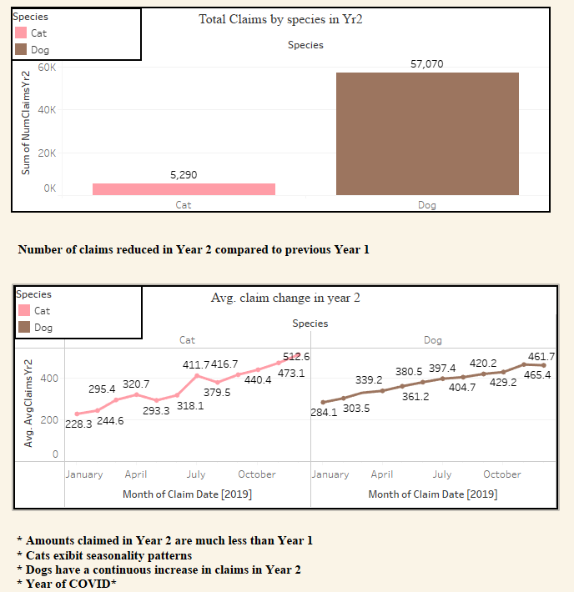

In Dashboard 4, we show the same analysis as in Dashboard 3, but only now we are showing data for the Year 2 or the year 2019. This year shows a small increase in total number of claims per species compared to the previous year, but the line chart showing the movement of average claim amount (in $) is drastically different. The average price starts very low in January for both species and then has almost completely linear increase until December of the same year. This can only be explained as an effect of COVID19 and measures that businesses and people had to adhere to. In the beginning of 2019, we know that people and businesses have limited their interaction with others and therefore the average claim amount was different. People would usually just stick for a short time, do basic checkups on their dogs and businesses mostly run discounts to attract customers. As the year moved on, people became more comfortable, and measures were alleviated, and people started taking their pets to the vets for all the checkups they have missed.

**Disparities in the insurance claim outcomes**

Finally, we tried to examine the disparities in insurance claim outcomes between cats and dogs. We first examined the percentage decrease in the amount claimed by policyholders compared to their initial claim requests. The average requested claim amount for cat owners stands at $877.40 as shown in fig 3 below, while the average amount actually claimed from the insurance company is $497.86. This results in a percentage difference of approximately 43%. In other words, cat owners receive about 43% less than what they initially requested. Contrastingly, dog owners display a substantial gap in their claim outcomes. The average requested claim amount for dogs is a substantial $1,606.41, whereas the average claimed amount is only $475.23. This leads to a staggering percentage difference of approximately 70%, meaning that dog owners receive around 70% less than their initial claim requests. Cat owners tend to have a significantly better chance of receiving higher claim amounts compared to dog owners. The percentage difference between the claimed and requested amounts for cat owners is notably lower, at 43%, suggesting a more favorable outcome for them. On the other hand, dog owners face a substantial disparity in their claim outcomes, with a remarkable 70.43% reduction from their initial claim requests.

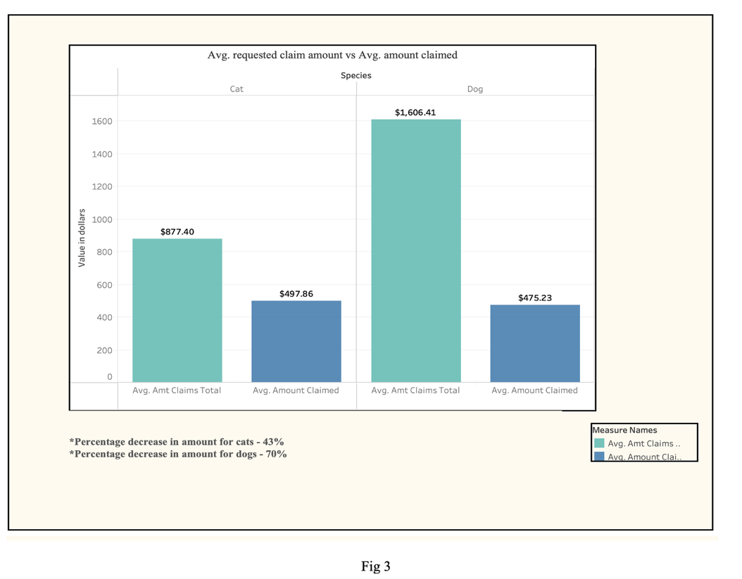

##### Conclusion & Recommendations

This project was a very interesting way of learning to understand data, and how they all correlate to each other to get a bigger picture of the situation, especially when working with smaller data samples.   
Our Pet Insurance project has revealed some interesting trends in the pet insurance industry as well as in the behavior of pets and their owners.   
  
Our Data Analysis section has shown that our insurance company mostly insures dogs with a cat to dog ratio of 1:5, and that the majority of claims are made by dog owners. We conducted an analysis of our customer population, meaning we dissected the population by species, breed, age in order to better understand the situation. Also, we were able to identify and order the breeds of dogs and cats that have visited the vet the most by analyzing the number of claims that were made for each breed. Additionally, we analyzed the pricing of our premiums in relation to the age of the insured pet. We did this because we wanted to find out does age influences the pricing of the premium and we found out that our insurance has a direct correlation between the age of the insured pet and the price of the premium. Meaning that premium increases with the age of the pet, but our analysis has found out that this shouldn’t be the practice since young and old pets need more attention and medical care, therefore these two groups need to have a more expansive premium.

This led us to investigate yearly changes in number of claims as well as change in the Dollar amount of claims for each species and we found out that they depend on the season, and the species because of their different biological needs, as well as unforeseen world events like Covid-19.

At the end we can say that our analysis has shown applicable information for both insurance and a potential customer. The analysis helps understand how prices of premiums change compared to the age of the pet but have also identified a need for insurance to adjust its premium pricing policy depending on the breed of the pet.

We recommend that the insurance company adjusts its pricing policy and makes it more flexible for their customers depending on the breed and age of their pet in order to attract customers who are looking for more flexibility. Additionally, the insurance company can use our analysis to identify a potential marketing strategy to attract more customers, especially cat owners.  
  
Potential recommendation for customers:  
Use this analysis just as informative tool to learn more about vet visits of your pet’s breed as well to identify the prices of premiums and potential changes in yearly needs of your dog.

References

* <https://www.forbes.com/advisor/pet-insurance/is-pet-insurance-worth-it/>
* <https://www.fortunebusinessinsights.com/industry-reports/pet-insurance-market-101956>